**FRAUDULENT TRANSACTION ANALYSIS USING SQL**

**1.Total number of fraud transactions**

SELECT COUNT(*) as Fraud_count

FROM fraud_detection.fraudtrain

WHERE is_fraud=1;



**2. Average fraud transaction amount**

SELECT ROUND(AVG(amt),2) as AVG_FRAUD_AMT

FROM fraud_detection.fraudtrain

WHERE is_fraud=1;

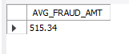

**3. Top 5 merchants by total fraud_amount**

SELECT merchant, SUM(amt) as Tot_fraud_amt

FROM fraud_detection.fraudtrain

WHERE is_fraud=1

GROUP BY merchant

ORDER BY Tot_fraud_amt DESC

LIMIT 5;

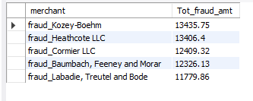

**4.Percentage of notable fradulent transactions per merchant**

SELECT*FROM(

SELECT merchant,(COUNT(CASE WHEN is_fraud=1 THEN 1 END)*100/count(*) )AS fraud_percent

FROM fraud_detection.fraudtrain

GROUP BY merchant

ORDER BY fraud_percent DESC) AS T

WHERE fraud_percent>1;

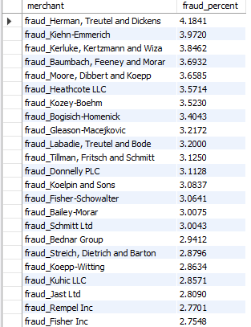

**5. Number of fraud transactions per month**

SELECT DATE_FORMAT(trans_date_trans_time, '%m') as month,COUNT(*) AS num_fraud_transact

FROM fraud_detection.fraudtrain

WHERE is_fraud=1

GROUP BY month

ORDER BY num_fraud_transact DESC;

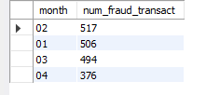

**6. TOP 5 cities with number of fraud transactions**

SELECT city,COUNT(*) as num_fraud_transact

FROM fraud_detection.fraudtrain

WHERE is_fraud=1

GROUP BY city

ORDER BY num_fraud_transact DESC

LIMIT 5;

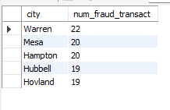

**7. Average fradulent transaction amount per card holder by gender**

SELECT gender,ROUND(AVG(amt),2)as avg_fraud_amt

FROM fraud_detection.fraudtrain

WHERE is_fraud=1

group by gender;

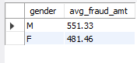

**8. highest risk merchant based on fraud percentage**

SELECT merchant,COUNT(*) as total_transactions,

SUM(CASE WHEN is_fraud=1 THEN 1 ELSE 0 END) AS fraud_transact,

(SUM(CASE WHEN is_fraud=1 THEN 1 ELSE 0 END)/COUNT(*))*100 AS fraud_percent

FROM fraud_detection.fraudtrain

GROUP BY merchant

ORDER BY fraud_percent DESC

LIMIT 1;



**9. Fraud patterns by time of day(top 6)**

SELECT HOUR(trans_date_trans_time) AS hour_of_day,COUNT(*) as total_transact,

COUNT(CASE WHEN is_fraud=1 THEN 1 END) as fraud_transact

FROM fraud_detection.fraudtrain

GROUP BY hour_of_day

ORDER BY fraud_transact DESC

LIMIT 6;

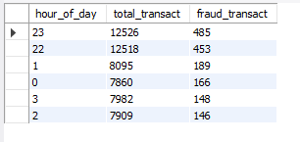

**10. Fraud numbers and percentage based on gender**

SELECT gender,COUNT(*) AS total_transactions,

COUNT(CASE WHEN is_fraud=1 THEN 1 END) AS num_fraud_transact,

(COUNT(CASE WHEN is_fraud=1 THEN 1 END)/COUNT(*))*100 AS fraud_percent

FROM fraud_detection.fraudtrain

GROUP BY gender;



**11. TOP fraud per category**

SELECT category,COUNT(*) as total_transact,

COUNT(CASE WHEN is_fraud=1 THEN 1 END) AS fraud_transact,

ROUND(COUNT(CASE WHEN is_fraud=1 THEN 1 END)*100/COUNT(*),2) as fraud_percent

FROM fraud_detection.fraudtrain

GROUP BY category

HAVING fraud_percent>1

ORDER BY fraud_percent DESC;

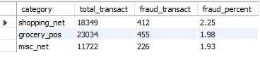

**12. Least fraud per category**

SELECT category,COUNT(*) as total_transact,

COUNT(CASE WHEN is_fraud=1 THEN 1 END) AS fraud_transact,

ROUND(COUNT(CASE WHEN is_fraud=1 THEN 1 END)*100/COUNT(*),2) as fraud_percent

FROM fraud_detection.fraudtrain

GROUP BY category

HAVING fraud_percent<1

ORDER BY fraud_percent;

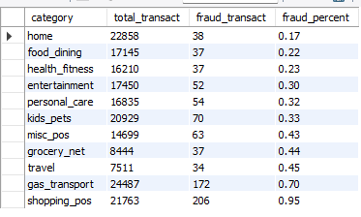

**12. TOP FRAUD percentage by state**

SELECT state,COUNT(*) AS total_transact,

COUNT(CASE WHEN is_fraud=1 THEN 1 END) as total_fraud_transact,

ROUND(COUNT(CASE WHEN is_fraud=1 THEN 1 END)*100/COUNT(*),2) AS fraud_percent

FROM fraud_detection.fraudtrain

GROUP BY state

HAVING fraud_percent>1

ORDER BY fraud_percent DESC;

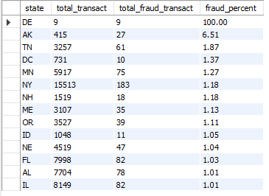

**13. NO FRAUD percentage by state**

SELECT state,COUNT(*) AS total_transact,

COUNT(CASE WHEN is_fraud=1 THEN 1 END) as total_fraud_transact,

ROUND(COUNT(CASE WHEN is_fraud=1 THEN 1 END)*100/COUNT(*),2) AS fraud_percent

FROM fraud_detection.fraudtrain

GROUP BY state

HAVING fraud_percent=0;

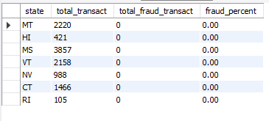

**14. least fraud percentage by state**

SELECT state,COUNT(*) AS total_transact,

COUNT(CASE WHEN is_fraud=1 THEN 1 END) as total_fraud_transact,

ROUND(COUNT(CASE WHEN is_fraud=1 THEN 1 END)*100/COUNT(*),2) AS fraud_percent

FROM fraud_detection.fraudtrain

GROUP BY state

HAVING fraud_percent>0 AND fraud_percent<1

ORDER BY fraud_percent DESC;

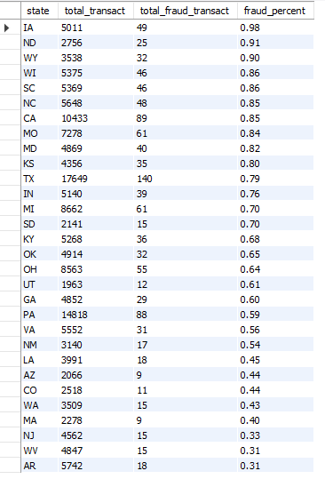

**CONCLUSION:**

We can deduce the following:

* Herman Terutel and Dickens have the highest fraud risk
* Warren is the city with most frauds
* Shopping_net,mic_net and grocery_pos has the highest risk of fraud.
* Delaware(DE) has the highest fraud rate with a 100% chance
* MT, MI, HS, VT, NV, CT, and RI states have no fraudulent transactions whatsoever.
* The home category has the least chance of fraud
* Males are more prone to fraud than women.
* Most of the fraud transactions occur at 22:00 and 23:00 hrs
* Kozey-Bohem and Heatchcote LLC have the highest fraudulent amount
* Most of the frauds occurred in January and February
* IA have the highest fraud rate

**Data Source**: [Kaggle fraud transactions data](https://www.kaggle.com/datasets/kartik2112/fraud-detection?select=fraudTrain.csv)

**By Saswata Maity**